Assignment for Chapter 3 Solution
- The accounting firm of Crawford and Associates has five senior partners. Yesterday the senior partners saw six, four, three, seven, and five clients, respectively.
- Compute the mean number and median number of clients seen by a partner.
- Is the mean a sample mean or a population mean?
- Verify that $\sum_{i=0}^{N}{\left(X_{i}-μ\right)=0}$
Answer: a. Mean=5, found by (6+4+3+7+5)/5
Median is 5, found by rearranging the values and selecting the middle value.
b. Population, because all partners were included.
c. $\sum_{i=0}^{N}{\left(X_{i}-μ\right)=\left(6-5\right)+\left(4-5\right)+\left(3-5\right)+\left(7-5\right)+\left(5-5\right)=0}$
2. Explain how the population mean, median, and mode compare when the population’s relative frequency curve is
a. Symmetrical
b. Skewed with a tail to the left
c. Skewed with a tail to the right
Answer: a. Equal or roughly equal.
b. The population mean is smaller than the population median, and the population median is smaller than the population mode.
c. The population mean is larger than the population median, and the population median is larger than the population mode.
3. In order to control costs, a company wishes to study the amount of money its sales force spends entertaining clients. The following is a random sample of six entertaining expenses (dinner costs for four people) from expense reports submitted by members of the sales force
$157 $132 $109 $145 $125 $139
- Show the equivalence of the following two formulas:
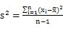 , 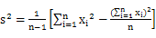.
- Calculate , , and s for the expense data, use the two different formulas in (a) to calculate.
- Assuming that the distribution of entertainment expenses is approximately normally distributed, calculate estimates of tolerance intervals containing 68.26 percent, 95.44 percent, and 99.73 percent of all entertainment expenses by the sales force.
- If a member of the sales force submits an entertaining expense (dinner cost for four) of $190, should this expense be considered unusually high (and possibly worthy of investigation by the company)? Explain your answer.
Answer: a.
b.
,
Another formula:
c. Estimate of tolerance interval containing 68.26 percent:
Estimate of tolerance interval containing 95.44 percent:
Estimate of tolerance interval containing 99.73 percent:
d. Yes, because $190 is not within the 99.73% interval [84.16, 184.39]
4. The manager of the local Wal-Mart Super Store is studying the number of items purchased by customers in the evening hours. Listed below is the number of items for a sample of 30 customers.
15 | 8 | 6 | 9 | 9 | 4 | 18 | 10 | 10 | 12
12 | 4 | 7 | 8 | 12 | 10 | 10 | 11 | 9 | 13
5 | 6 | 11 | 14 | 5 | 6 | 6 | 5 | 13 | 5
- Use software (SPSS or EXCEL) to find the mean and the median of the number of items.
- Use software (SPSS or Excel) to find the range and the standard deviation of the number of items.
- Use software (SPSS or Excel) to find the first quartile, third quartile and IQR and construct the box-plot. Are there any outliers?
Answer: a, b:
Descriptive statistics
 | # 1
count | 30
mean | 9.10
sample variance | 12.71
sample standard deviation | 3.57
minimum | 4
maximum | 18
range | 14
1st quartile | 6.00
median | 9.00
3rd quartile | 11.75
interquartile range | 5.75
c. No outliers.
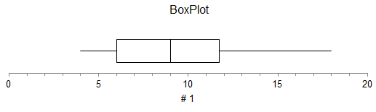

5. A group of 13 students is studying in Istanbul, Tukey, for five weeks. As part of their study of the local economy, they each purchased an Oriental rug and arranged for its shipment back to the United States. The shipping time, in days, for each rug was
31 31 42 39 42 43 34
30 28 36 37 35 40
Estimate the percentage of days that are within two standard deviations of the Mean. Is it likely to take 2 months for a delivery?
Answer：
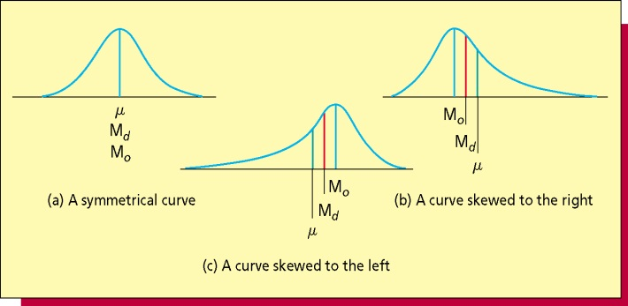
a. Because the mean equals to the median 36, we can assume the distribution of data is symmetric.
b. Since the distribution is symmetric, we can estimate 95.44 percent of days that are within two standard deviations of the Mean.
c. The mean equals to 36, Standard Deviation equals to 5. The interval within three standard deviations of the Mean is [36-3*5, 36+3*5] = [21, 51].
It means 99.73 percent of the days lie in the interval [21, 51].
So 2 months (60 days) is unlikely for a delivery.

6. Thirteen internists in the Midwest are randomly selected, and each internist is asked to report last year’s income. The incomes obtained (in thousands of dollars) are 152, 144, 162,154, 146, 241, 127, 141, 171, 177, 138, 132, 192. Find:
  - The 90th percentile.
  - The median.
  - The first quartile.
  - The third quartile
  - The 10th percentile.
  - The inter-quartile range.
  - Develop a five-number summary and a box-and-whiskers display.
Answer: There are 13 measurements in total (n=13). First, arrange the measurements in increasing order:
127 | 132 | 138 | 141 | 144 | 146 | 152 | 154 | 162 | 171 | 177 | 192 | 241

- The 90th percentile.
Calculate the index of the 90th percentile:
Round 11.7 up to 12, hence the 90th percentile is the 90th measurement 192.

- The median.
The median is equivalent to the 50th percentile:
Round 6.5 up to 7, hence the median is the 7th measurement 152.

- The first quartile.
We know the index of the first quartile can be found as:
Round 3.25 up to 4, hence the first quartile is the 4th measurement 141.

- The third quartile
We know the index of the third quartile can be found as:
Round 9.75 up to 10, hence the third quartile is the 10th measurement 171.

- The 10th percentile.
Calculate the index of the 10th percentile:
Round 1.3 up to 2, hence the 10th percentile is the 2nd measurement 132.

- The interquartile range.
Interquartile range is the difference between first and third quartile
- Develop a five-number summary and a box-and-whiskers display.
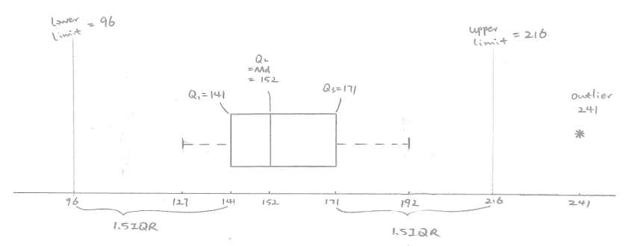
7. Consider three stock funds, which we will call Stock Funds 1, 2, and 3.Suppose that Stock Fund 1has a mean yearly return of 10.93 percent with a standard deviation of 41.96 percent, Stock Fund 2 has a mean yearly return of 13 percent with a standard deviation of 9.36 percent, and Stock Fund 3 has a mean yearly return of 34.45 percent with a standard deviation of 41.16 percent.
a. For each fund, find an interval in which you would expect 95.44 percent of all yearly returns to fall. Assume returns are normally distributed.
b. Using the intervals you computed in part a, compare the three funds with respect to average yearly returns and with respect to variability of returns.
c. Calculate the coefficient of variation for each fund, and use your results to compare the funds with respect to risk. Which fund is riskier?
Answer: a. Assume returns are normally distributed, according to the empirical rule, 95.44 percent of all yearly returns are within two standard deviations of the Mean and thus lie in the interval
Fund 1: [10.93 – 2*41.96, 10.93 + 2*41.96] = [–72.99, 94.85]
Fund 2: [13 – 2*9.36, 13 + 2*9.36] = [–5.72, 31.72]
Fund 3: [34.45 – 2*41.16, 34.5 + 2*41.14] = [–47.87, 116.77]
b. Fund 1 has the lowest average and highest variability.
Fund 2 has the second lowest average and the smallest variability.
Fund 3 has the highest average return and the second highest variability.
c. We compute the coefficient of variation for these three funds using,
Fund 1: Coefficient of Variation = 41.96 / 10.93 * 100 = 383.9%
Fund 2: Coefficient of Variation = 9.36 / 13 * 100 = 72%
Fund 3: Coefficient of Variation = 41.14 / 34.45 * 100 = 119.5%
Fund 1 is the riskiest, fund 3 is the second and fund 2 is least risky.
8. The following table gives a summary of the grades received by a student for the first 64 semester hours of university coursework. The table gives the number of semester hours of A, B, C, D, and F earned by the student among the 64 hours.
Grade | Number of Hours
A (that is, 4.00) | 18
B (that is, 3.00) | 36
C (that is, 2.00) | 7
D (that is, 1.00) | 3
F (that is, 0.00) | 0
- By assigning the numerical values, 4.00,3.00,2.00,1.00 and 0.00 to the grades A, B, C, D, and F (as shown), compute the student’s grade point average for the first 64 semester hours of coursework.
- Why is this weighted average?
Answer: a. The numerical values for grades A, B, C, D, and F are , and the weights applied to these measurements are .
That is, we are weighting the numerical values of grades by the number of hours. The weighted mean is computed as follows:
- This is a weighted mean because the different grade values are weighted by the number of credit hours.
9. The Rivertown city council is attempting to choose one of four sites (A, B, C, or D) as the location for its new emergency facility. After the new emergency facility becomes available for service, the current emergency facility will be shut down. The project manager has estimated the following response times in minutes from each of the proposed sites to the four areas that must be served by the emergency facility.
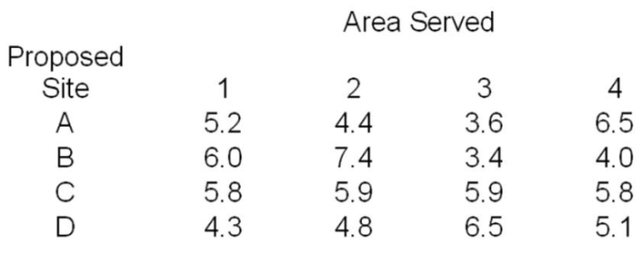
The number of emergency runs from the current emergency facility to each of the four areas over the past year is as follows:
Compute the weighted mean response time from the proposed locations and determine which proposed site should be selected for the new emergency facility.
Answer: The response times in minutes for site A are , and the weights applied to these measurements are .
That is, we are weighting the response times by the number of emergency runs. The weighted mean is computed as follows:
4.76
Similarly,
Since the weighted mean response time from location A is the smallest, site A should be selected for the new emergency facility.
10. The average life of Canadian women is 73.75 years, and the standard deviation of women's life expectancy in Canada is 6.5 years.
a. Using Chebyshev's Theorem, determine the minimum percentage of women in Canada whose life expectancy is between 64 and 83.5 years.
b. Based on Chebyshev's inequality, determine the upper and lower bounds on the average life expectancy of Canadian women such that at least 90 percent of the population is included.
Answer: a. Determine the value of k: (73.75 ± k(6.5)); k = 1.5
(1 - (1/k2) = 1 - (1/2.25) = .5556, or 55.56%
b.
